(APprox. 157 words)

Windows 8/8.1 Corner
Customize the Text on Your PC
By Rosita Herrick, Yahoo Forum Moderator, Sarasota Technology User Group, FL
http://thestug.org/
Rosita (at) thestug.org

Font sizes:

If the default size of text on your PC, especially on laptops, is small and hard to read, here are the steps to increase it.

Right click on any empty part of the desktop wall paper

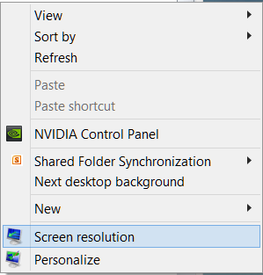

Click on Screen resolution and the click on Make text and other items larger or smaller.

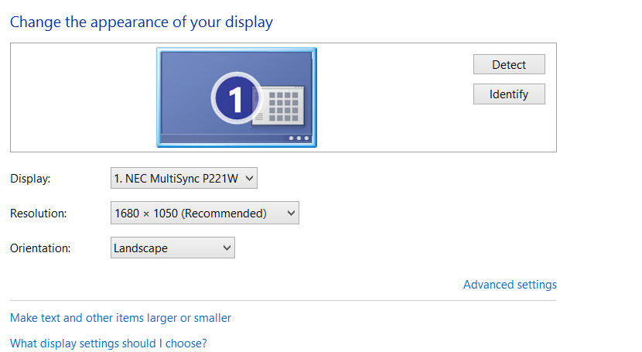

On this new window there are a few choices:

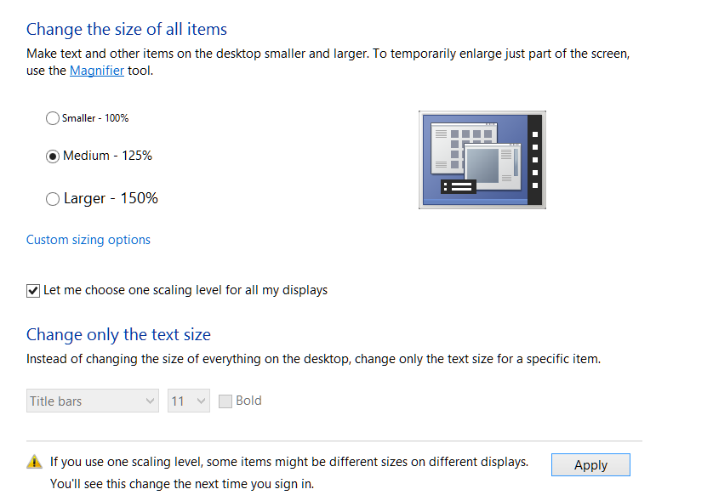

You can click on the checkbox and get the choice of size you want to increase for all items or
leave the box blank, and as shown below, change the font of specific items

In the Items box I chose Menus, checked the Bold box, and then checked Apply

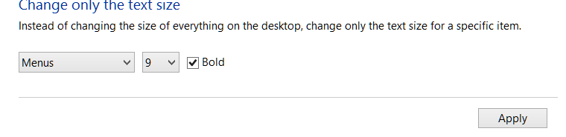

Here are the before and after results:

Before

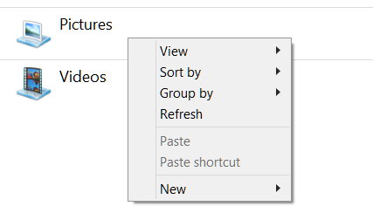

After

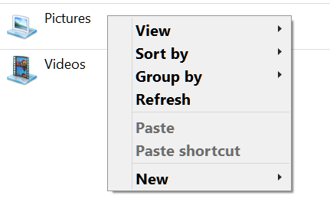
Reminder: Don’t forget to click on the Apply box to finalize the change.

